Date access: 2020-03-10

<http://wjw.beijing.gov.cn/wjwh/ztzl/xxgzbd/gzbdyqtb/202002/t20200202_1622729.html>

From 24:00 on February 1 to 12:00 on February 2, 8 new cases of pneumonia infected with new coronavirus were added to the city

Date: 2020-02-02 Source: Beijing Municipal Commission of Health

        From 24:00 February 1st to 12:00 on February 2nd, 8 new pneumonia cases of new coronavirus infection were added to the city, 4 cases had contact history in Hubei and other provinces, and 4 were close contacts of confirmed cases. All have been sent to designated medical institutions for treatment.

As of 12:00 on February 2nd, a total of 191 confirmed cases have been confirmed in the city, including 1 death, 9 discharges, and 181 cases in isolated hospitals. 3 cases in Dongcheng District, 22 cases in Xicheng District, 35 cases in Chaoyang District, 41 cases in Haidian District, 16 cases in Fengtai District, 5 cases in Shijingshan District, 2 cases in Mentougou District, 2 cases in Fangshan District, 13 cases in Tongzhou District, 6 cases in Shunyi District, There were 12 cases in Changping District, 22 cases in Daxing District, 1 case in Huairou District, and 11 cases came from overseas. No cases have been reported in Pinggu District, Miyun District and Yanqing District.

**2月1日24时至2日12时，本市新增8例新型冠状病毒感染的肺炎病例**

日期：2020-02-02 来源：北京市卫生健康委‍

        2月1日24时至2日12时，本市新增8例新型冠状病毒感染的肺炎病例，4例有湖北及其他省份接触史，4例为确诊病例的密切接触者。均已送至定点医疗机构进行救治。

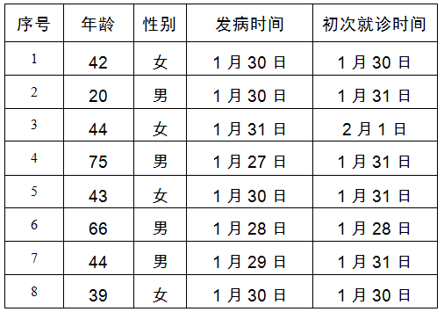

        截至2月2日12时，本市累计确诊病例191例，其中死亡1例，出院9例，181例在定点医院进行隔离治疗。东城区3例、西城区22例、朝阳区35例、海淀区41例、丰台区16例、石景山区5例、门头沟区2例、房山区2例、通州区13例、顺义区6例、昌平区12例、大兴区22例、怀柔区1例、外地来京人员11例。平谷区、密云区、延庆区尚未有病例。